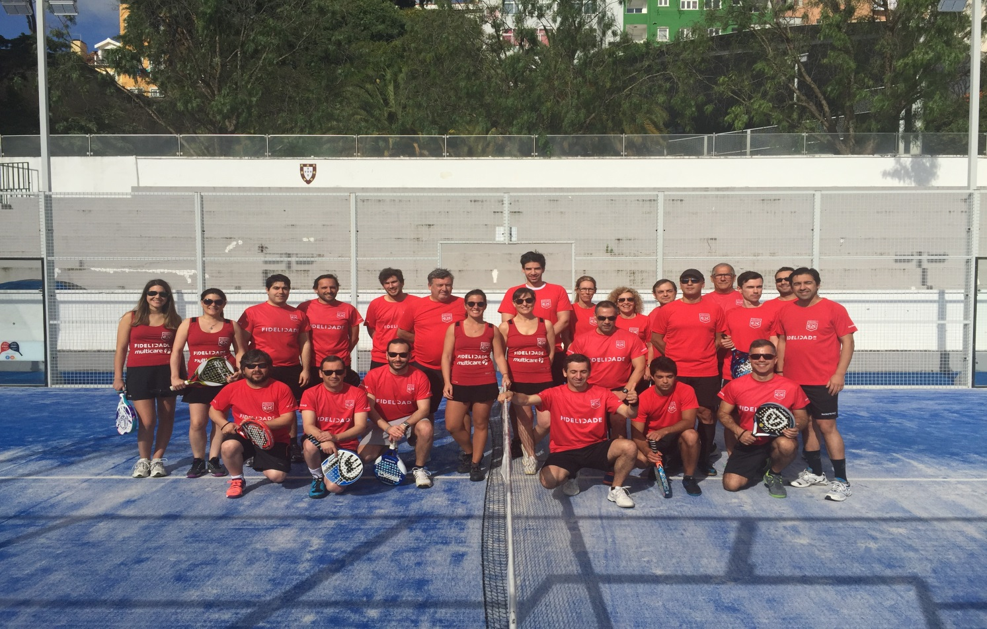

**Secção de Padel**

O GDC proporciona aos seus associados a possibilidade de praticar Padel assim, após o sucesso da Secção informamos que estão abertas as inscrições **até 19 de Setembro de 2016,** para todos aqueles que se queiram juntar **a Nós**.

É fácil de praticar, basta ter algumas noções básicas sobre os aspetos técnicos e táticos para que todos se possam divertir durante o jogo. A secção de Padel irá ter três vertentes: aulas, jogo de lazer e competição (Torneios). As atividades realizam-se no Nacional Padel na rua de S. Bento. (Clube Nacional de Natação)

Os responsáveis desta modalidade são os colegas da Multicare Rui Martins e Diana Mota.

Os sócios interessados deverão preencher esta ficha de inscrição e enviar para os emails: [grupo.desportivo.reservas@fidelidade.pt](mailto:grupo.desportivo.reservas@fidelidade.pt); [Diana.Ferreira.Mota@multicare.pt](mailto:Diana.Ferreira.Mota@multicare.pt) até dia **19 Setembro.**

|  |  |  |  |  |  |  |  |  |  |  |  |  |  |  |  |  |  |  |  |  |  |  |  |  |  |  |  |  |  |  |  |  |  |  |  |  |  |  |  |  |  |  |  |  |  |  |  |  |  |  |  |  |  |  |  |  |  |  |  |  |  |  |  |  |  |  |  |  |  |  |  |  |  |  |  |  |  |  |  |  |  |  |  |  |  |  |  |  |  |  |  |  |  |  |  |  |  |  |  |  |  |  |  |  |  |  |  |  |  |  |  |  |  |  |  |  |  |  |  |  |  |  |  |  |  |  |  |  |  |  |  |  |  |  |  |  |  |  |  |  |  |  |  |  |  |  |  |  |  |  |  |  |  |  |  |  |  |  |  |  |  |  |  |  |  |
| --- | --- | --- | --- | --- | --- | --- | --- | --- | --- | --- | --- | --- | --- | --- | --- | --- | --- | --- | --- | --- | --- | --- | --- | --- | --- | --- | --- | --- | --- | --- | --- | --- | --- | --- | --- | --- | --- | --- | --- | --- | --- | --- | --- | --- | --- | --- | --- | --- | --- | --- | --- | --- | --- | --- | --- | --- | --- | --- | --- | --- | --- | --- | --- | --- | --- | --- | --- | --- | --- | --- | --- | --- | --- | --- | --- | --- | --- | --- | --- | --- | --- | --- | --- | --- | --- | --- | --- | --- | --- | --- | --- | --- | --- | --- | --- | --- | --- | --- | --- | --- | --- | --- | --- | --- | --- | --- | --- | --- | --- | --- | --- | --- | --- | --- | --- | --- | --- | --- | --- | --- | --- | --- | --- | --- | --- | --- | --- | --- | --- | --- | --- | --- | --- | --- | --- | --- | --- | --- | --- | --- | --- | --- | --- | --- | --- | --- | --- | --- | --- | --- | --- | --- | --- | --- | --- | --- | --- | --- | --- | --- | --- | --- | --- | --- | --- |
| **Ficha de Inscrição** | | | | | | | | | | | | | | | | | | | | | | | | | | | | | | | | | | | | | | | | | | | | | | | | | | | | | | | | | | | | | | | | | | | | | | | | | | | | | | | | | | | | | | | | | | | | | | | | | | | | | | | | | | | | | | | | | | | | | | | | | | | | | | | | | | | | | | | | | | | | | | | | | | | | | | | | | | | | | | | | | | | | | |
|  |  | |  | |  | |  | | | | |  | | |  | | | | |  | | |  | | |  | |  | | |  | | |  | | | |  | | | |  | | | |  | | | |  | | |  | |  | | |  | | |  |  | | | |  | | | |  | | |  | | |  | | | |  | | | |  | | | |  | | |  | | | |  | | |  | | | |  | | | | | |  | | | | |  | | | | | | | | | | | | | | | | |  | | | | | |  | | | |  | |  | | | | |  | | |  | | |  | | | | |  | | |  | |  |  | |  | | | | |  | | | | |
| **Nome:** | | | | |  | |  | | | | | | | | | | | | | | | | | | | | | | | | | | | | | | | | | | | | | | | | | | | | | | | | | | | | | | | | | | | | | | | | | | | | | | | | | | | | | | | | | | | | | | | | | | | | | | | |  | | | | | | **Nº Sócio:** | | | | | | | | | | | | | | | | | | | | | | | |  | | | | | | | | | | | | | | | | | | | | | | | | | | |  | | | | | | | | |  | | | | | | | | | | | | | | | | | | | | | | | | | | | | | | | | | | |
|  |  | |  | |  | |  | | | | |  | | |  | | |  | | | | |  | | |  | |  | | |  | | |  | | | |  | | | |  | | | |  | | | |  | | |  | |  | | |  | | |  |  | | | |  | | | |  | | |  | | |  | | | |  | | | |  | | | |  | | |  | | | |  | | |  | | | | |  | | | | |  | | | | |  | | | | | | | | | | | | | | | | |  | | | |  | | | | | |  | |  | | | | |  | | |  | | |  | | | | |  | | |  | |  |  | |  | | | | |  | | | | | | | | | | | | | | | | | | | | | | | | | | | | | | | | |
| **Data de Nascimento:** | | | | | | | | | | | | | | | | | | | | | | | | | |  | | | | | | | | | | | | | | | | | | | | | | | | | | | | | | | | | | | |  | | | |  | | | |  | | |  | | |  | | | |  | | | |  | | | |  | | |  | | | | | | | | | | | |  | | | | |  | | | | |  | | | | | | | | | | | | | | | | |  | | | |  | | | | | |  | |  | | | | |  | | |  | | |  | | | | |  | | |  | |  |  | |  | | | | |  | | | | | | | | | | | | | | | | | | | | | | | | | | | | | | | | |
|  | | | | | | | | | |  | | | | | |  | | | | | |  | | | | |  | | |  | | | | |  | | | | |  | | | |  | | | |  | | | | | |  | | |  | |  | | | |  | | | |  | | | | |  | | | | |  | | | |  | | | |  | | | | |  | | | |  | | | | |  | | | | |  | | | | | | | |  | | | | |  | | |  | | | |  | | | |  | | | |  | | | | |  | | | |  | | |  | |  | | | | |  | | | |  | | | | | | | | | | | | | | |  | | | |  | | | | |  | | |  | | | | |  | |  | |  | |  | |  | |  |  | |  | | |  |
| **Estou interessado em:** | | | | | | | | | | | | | | | | | | | | | | | | | | |  | | | **Aulas** | | | | | | | | | | | | | |  | | | |  | | | | | |  | | |  | |  | | | | **Jogo de Lazer** | | | | | | | | | | | | | | | | | | | | | |  | | | | |  | | | |  | | | | |  | | | | |  | | | | | | | | **Torneio** | | | | | | | | | | | | | | | | | | | |  | | | | |  | | | |  | | |  | |  | | | | |  | | | |  | | | | | | | | | | | | | | |  | | | |  | | | | |  | | |  | | | | |  | |  | |  | |  | |  | |  |  | |  | | |  |
|  | | | | | | | | | |  | | | | | |  | | | | | |  | | | | |  | | |  | | | | |  | | | | |  | | | |  | | | |  | | | | | |  | | |  | |  | | | |  | | | |  | | | | |  | | | | |  | | | |  | | | |  | | | | |  | | | |  | | | | |  | | | | |  | | | | | | | |  | | | | |  | | |  | | | |  | | | |  | | | |  | | | | |  | | | |  | | |  | |  | | | | |  | | | |  | | | | | | | | | | | | | | |  | | | |  | | | | |  | | |  | | | | |  | |  | |  | |  | |  | |  |  | |  | | |  |
| **Email:** | | | | | | | |  | | | | | | | | | | | | | | | | | | | | | | | | | | | | | | | | | | | | | | | | | | | | | | | | | | | | | | | | | | | | | | | | | | | | | | | | | | | | | | | | | | | | | | | | | | | | | | | | | |  | | | | | | | | | | | |  | | | |  | | | |  | | | | | | | | | | | | | | | | | | | | | | | | | | | |
|  | | | | | |  | | | | |  | | |  | | | | |  | |  | | | |  | | |  | | | |  | | | |  | | |  | |  | | | |  | | | |  | | |  | | | | | | | | | | | | |  | | | |  | |  | | | |  | | | |  | | | |  | | |  | | |  | | | |  | | | |  | | |  | | | | |  | | | | |  | | | | |  | | | |  | | |  | | |  | | | |  | | | | | |  | | | |  | | | | | | | | |  | | | | | | | |  | | |  | | |  | | |  | |  | | | | |  | | |  | | |  | | |  | |  |  | |  | | | | | | | | | | | | | | | | | |
|  | |  | |  | | | | |  | | | |  | | | |  | | | | | | |  | | | | |  | | | |  | | | |  | | | | | |  | | | |  | | | |  | | | | |  | | | |  | | | |  | | | |  | | | | | |  | | | |  | | | |  | | | | |  | | | | |  | | | |  | | | | |  | | | | | |  | | | | | | |  | | | | | | |  | |  | | | |  | | | |  | | | | | | |  | | | | |  | |  | | | | | | |  | | | | |  | | | | | | | | | | |  | | | | |  | | | |  | | |  | | | | |  | | |  | |  | |  | |  | |  | | |  | |  |  | |
| **Assinatura:** | | | | | | | | |  | | | | | | | | | | | | | | | | | | | | | | | | | | | | | | | | | | | | | | | | | | | | | | | | | | | | | | | | | | | | | | | | | | | | | | | | | | | | | |  | | **Contacto:** | | | | | | | | | | | | | | | | | | | | | |  | | | | |  | | | | | | | | | | | | | | | | | | | | | | | | | | | **Data:** | | | | | |  | | | | | | | | | | | | | | | | | | |